Breathalyzer Design

**Van Do**

Team Members: Conner Brentzel, Joshua Danyeur, and Scott Adamson

Excelsior College

ELEC495

Integrated Technology Assessment

Jianxin Tang, Ph.D.

December 2022

**Introduction**

**Team Report**

Conner Brentzel will use a light sensor module in order to determine if a vehicle is approaching a traffic light that is transitioning from green to yellow and finally to red. The thought is to include an ultrasonic sensor in order to determine if the vehicle is close to the traffic light and will emit an alert audibly via a speaker and visually via a LCD.

Joshua Danyeur will build a simple switch mode power supply to take the 120V AC from a home outlet and turning it into a 24V DC signal; utilizing a transformer and a few circuit parts.

Scott Adamson will create a sensor system that will detect and alert an object’s whereabouts in regards to the device.

**Abstract**

This project will aim to build a breathalyzer used to detect the level of alcohol in the body system. It is not enough to face the consequences of inhibition when it is too late, and a driver is pulled over. Instead, responsible drinkers can use this device to judge a tolerable level of sobriety before leaving. This can be used wherever there is nightlife, or a gathering of friends in which alcohol is served. Measuring blood alcohol content (BAC) is all but reliable in terms of weight,

What encapsulates this project is the materials needed to accomplish functional breathalyzers that police often use. Additionally, the project will aim to serve as a learning challenge as PCB design will be implemented into the overall product. This endeavor focuses on aiming to learn PCB design that was not available as a course at Excelsior University. This will result in well-rounded knowledge of electronics as a focus in the major.

**Background**

An Arduino Uno R3 will be used to develop the device using an FDA approved commercial breathalyzer, called BACtrack, as reference (BACtrack GO, N.D.). To justify the feasibility of this project, the components are easily exchangeable if any were to fail, while regular periods of calibration are required for the commercial alternative. The components include a piezo buzzer, an LCD module, and an MQ3 Gas Sensor. This will be fitted onto a custom designed PCB for ease of use. According to the datasheet on the MQ-3, it is a SnO2 semiconductor which features lower conductivity in clean air. In the presence of gasses, the conductivity rises and can be programmed to measure BAC (Alcohol Gas Sensor, 2014).

A study was conducted to determine the overall perception of a personal breathalyzer. Min, A., et al, showed that young adults below the age of 34 that are at risk of the consequences of binge drinking are highly receptive towards a personal device that helps aid in decision making (Min, A, et al, 2020). This project will aim to produce a device that is a cheaper alternative that still delivers accurate results in hopes of curbing harmful decision making. This project is inspired by personal experiences in the military where alcohol related incidents result in detrimental outcomes for the unit and individual. Therefore, engineering a device that could potentially save a fellow soldier will also impact the welfare of society as a whole.

**Project Objectives**

The project aims to solve the following objectives:

1. Design an affordable alcohol measurement device to determine sobriety.
2. Promote proactive use by having the device available in common areas where alcohol is served.
   1. Additionally, the device should be portable and easy to use.
3. Decrease the number of alcohol related incidents in society.

**Design Methodology**

**Project Timeline**

**GANTT Chart:**

Figure 1 - Gantt Chart for M2Project Report

Following this timeline, I expected the earliest to be done with my design is in early November. I also expected timeline changes as this proved to not be realistic. My actual date of completion turned out to be two weeks from the estimated date of the Gantt Chart, late in November.

**PERT Chart:**

Figure 2 - Pert Chart for M2Project Report

This chart is an accurate representation of the direction this project followed as the design was worked in phases. Component research was crucial to the development of later phases and provided insight in the overall operation of the inter-operation of the Breathalyzer. Prototyping the circuit with both software simulation and physical breadboard guided the placement of components when learning PCB design. Testing and debugging the code through multiple trials solidified correct signal operation to deliver accurate measurements.

**Flow Chart**

Figure 3 - Logical flowchart of Breathalyzer

Figure 1 shows an illustration of the approach of the program that will later be developed. The PCB will need an overall review of what components will be implemented and how to fit the components into the design. This was learned and demonstrated by the end of the project to include design engineering and soldering. The overall concept is to take the conductivity of the sensor during clean air and develop a comparator circuit in the presence of alcohol. Then, the input should be programmed to convert the signal into the equivalent result in alcohol per mg/l, and later BAC as a percentage. The formula for conversion was later developed as the design was further researched. As a result, additional features were added to this flow chart to indicate stages of intoxication. The stages follow as nothing detected below a set threshold, .03% to .08% to suggest drinking water, and lastly greater than .08% to alert a high level of intoxication along with the sounding of the piezo buzzer.

**Block Diagram**

**Arduino Uno Rev3**

The Arduino is an ATmega328P based microcontroller unit that features 14 digital I/O pins and 6 analog inputs to be used for the components of a breathalyzer device. The device uses embedded C programming to interact with its peripherals. The device’s power will be sourced by an external power bank in lieu of a battery source. This is to save time on the constraints of this project.

Figure 4 - Arduino Uno R3 visual

**MQ-3 Alcohol Gas Sensor**

This sensor will detect the presence of alcohol in the air through conductivity of the SnO2 semiconductor. The sensor module houses a comparator circuit that outputs a signal to pins 2 and 3. Pin 2 will detect any conductivity beyond a threshold set by the onboard potentiometer. The technical data illustrates lowered resistivity when in the presence of gases, which translates to a higher output signal at the pin. This signal will be converted into an equivalent BAC percentage value displayed on the 16x2 LCD module. According to Ighalo, J. et al., their analysis of the MQ-3 module details the operation of the output signal:

“Instead of measuring the resistance directly, we measure the voltage level at the point between the sensor and a load resistor R2. The sensor and load resistor R2 form a voltage divider, and the lower the sensor resistance, the higher the voltage reading which was then fed directly into the input of the LM393 comparator.” (P. 73)

Figure 5 - MQ-3 Sensor Rs/R0 per mg/L of alcohol

(Technical Data MQ-3 Gas Sensor, N.D.)

**LCD 1602 16x2 Module**

The LCD module will take the resulting converted signal to be displayed on the screen structured by the developed C program. The pin description detailed on the datasheet proved useful to guide the circuit design discussed later *(*Specifications of LCD Module, 2008).This is to include a 10k potentiometer to adjust screen brightness. To follow the theme of device portability, the overall project design aims to place the LCD module on top of a custom-built PCB. What is displayed is the resulting conversion from breath alcohol content to blood alcohol content, measured to the third significant figure.

Figure 6 - LCD Pin Layout

**Piezo Buzzer**

The CEP-1130 piezo buzzer is also placed on top the PCB to alert the tester of legal intoxication (>=.08%). This will chirp intermittently in order to catch the user’s attention.

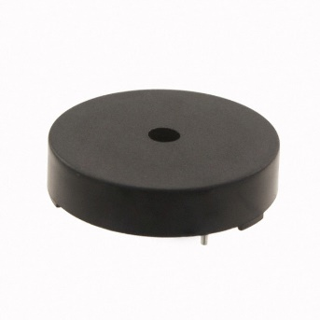

Figure 7 – Model CEP-1130

**Breathalyzer Block Diagram**

A simulated circuit has been drawn via LTSpice to prepare for physical connection on a breadboard to prototype connection and placement on a PCB. This is also to confirm correct operating procedures. Coding will then commence to follow the flowchart detailed earlier. The code will define each input/output port and will output the results of the converted detected alcohol signal from the MQ3 gas sensor. This will be converted by the microcontroller into an appropriate BAC in order to help determine sobriety. Although the sensor returns a signal in a range of 25 – 500 ppm, an equivalent value in the form of BAC percentage will help achieve project goals along with ease of interpretation of measurements.

Figure 8 - Block Diagram of Breathalyzer via EasyEDA

**Software**

#include <LiquidCrystal.h>

#include <Wire.h>

#define piezo 9

const int rs = 12, en = 11, d4 = 2, d5 = 3, d6 = 4, d7 = 5; // declaring LCD pins

LiquidCrystal lcd(rs, en, d4, d5, d6, d7);

void setup() {

pinMode (piezo, OUTPUT); // declaring peripheral I/O ports

pinMode (0, INPUT);

Serial.begin(9600);

lcd.begin(16, 2); // initiallizing 16x2 LCD module

lcd.print("Sensor warming.."); // Allowing heating current to warm the sensor

delay(60000);

lcd.clear(); // Clear LCD screen for test results

}

void loop() {

float SensorValue = analogRead(0);

float Breath = SensorValue / 1024;

float ratio = .21; // conversion of presence of alcohol per liter in blood

float BAC = Breath * ratio;

Serial.println(SensorValue); // monitoring values for testing & debugging

Serial.println(Breath,3); // precision decimal points

Serial.println(BAC,3); // precision decimal points

if (BAC >.079) // Drunken limit

{

lcd.clear();

lcd.setCursor(0,0);

lcd.print("BAC = ");

lcd.print(BAC); // extra spaces are intentional for clearing row of unnecessary characters

lcd.print("% ");

lcd.setCursor(0,1);

lcd.print("DO NOT DRIVE ");

digitalWrite(9, HIGH);

delay(250);

digitalWrite(9, HIGH);

delay(250);

digitalWrite(9, HIGH);

}

else if ((BAC > .02) && (BAC < .079)) // threshold for detected drunkeness

{

lcd.clear();

lcd.setCursor(0,0); // first line measurements

lcd.print("BAC = ");

lcd.print(BAC); // extra spaces are intentional for clearing row of unnecessary characters

lcd.print("% ");

lcd.setCursor(0,1);

lcd.print("DRINK WATER ");

}

else { // Below the limit

lcd.clear();

lcd.setCursor(0,0); // first line measurements

lcd.print("BAC = 0.00% ");

lcd.setCursor(0,1);

lcd.print("NOT DETECTED "); // extra spaces are intentional for clearing row of unnecessary characters

}

}

The above program written in embedded C describes the operation of the breathalyzer as it converts an input signal to its equivalent BAC percentage value. A formula needed to be developed to correctly display the measurement as a BAC value. In their analysis of the MQ-3 gas sensor, Ighalo, J. et al. specify that the analog pins have a total value range of 1024 (March, 2019). Additionally, according to the commercially available breathalyzer BACtrack, “the ratio of breath alcohol [BrAC] to blood alcohol is generally estimated to be 2,000:1. Therefore, 2,100 milliliters (ml) of alveolar air will contain approximately the same amount of alcohol as 1 ml of blood” (*BACtrack GO* N.D.). However, BAC will be expressed as mg/L; for every mg of alcohol present in the breath, there is 2100mg of alcohol present in blood. Therefore, the following formula is derived:

Depending on the value of the resulting measurement, the program will output a message based on the level of intoxication: NOT DETECTED, DRINK WATER, and DO NOT DRIVE.

**Hardware**

Throughout the development of the circuit design, multiple iterations were performed in order to find the most efficient setup. First, an initial setup was performed to verify operation and communication between different components. This helped solidify testing and debugging in consideration of declaring I/O pins, along with operational hierarchy when developing the core statements.

Figure 9 - Device powered on and sample code loaded.

The next stage of the process incorporated the developed C Program followed by testing and debugging the formula when supplied with an input signal from the MQ-3 sensor. This portion of the project presented the most challenging hurdle as the formula needed to be reworked from a previous iteration. At the same time, this stage also presented one of the most valuable learning experiences as it was overcome, to be detailed later.

Figure 10 - Working device under presence of alcohol

**PCB Design**

Figure 11 - Custom PCB design for breathalyzer device

After both the software and hardware of the breathalyzer device was developed to a satisfactory level of operation, PCB design was learned in order to support project objectives of being accessible and easy to use. The important lessons from self-learning include that everything should be evenly spaced in order to avoid manufacturing issues and cross-coupling. Track size and pathing should also be considered depending on the requirements of the board. Lastly, optimal placement of components on the PCB determine whether tracks will have efficient connections. Here, pins on the LCD module had to be repositioned in order to better accommodate other components on a custom-built PCB.

My circuit board has been designed using EasyEDA. This circuit board will fit on top the Arduino microcontroller and will house all the components necessary for a functioning breathalyzer. It also has space for a switch to reset the device after a test. In the middle of the board lies pins for an LCD module that is supported by a potentiometer and 1k Ohm resistor to adjust the brightness of the screen. Lastly, the sensor module pictured on the right of Figure 11 will be soldered to the pads on the right of the board using Dupont wires as a means of ease of use while using the breathalyzer.

**Soldering**

With all the components ordered after PCB design was complete, soldering began to finalize the development of the Breathalyzer device. A 30-minute video was captured of the soldering process to include in the final presentation. This will be fast-forwarded in order to show the main portions and analyze what went right and what could have been done better.

Figure 12 - Front of Board Soldering

Figure 13 - Back of Board Soldering

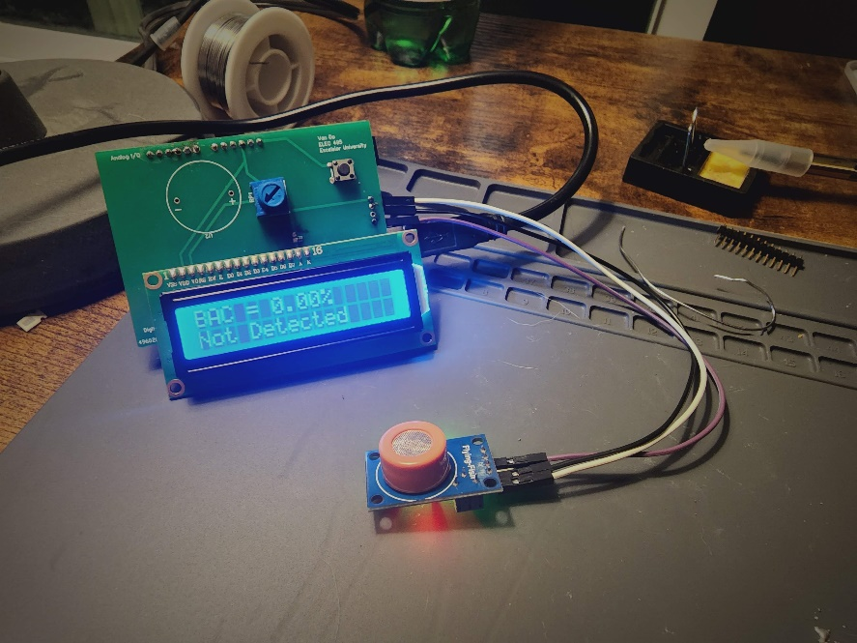

Figure 14 – Completed & Powered on Breathalyzer

Upon completion of soldering, a noticeable issue is that the sensor takes about three minutes to fully warm up and exhibit high resistance in clean air. Unless the device has an adequate amount of time to warm up, the breathalyzer will display a false positive by showing alcohol detected in clean air. In comparison to commercially available breathalyzers, this presents a major inconvenience. I am certain this is due to the length of the wire from the microcontroller to the sensor module, as it was overlooked that longer lengths of wire increase resistance.

**Testing**

For the purposes of video presentation, testing will consist of recording the presence of isopropyl alcohol on a wet Q-tip. The video shows how the sensor reacts to gases and display the varying levels of alcohol presence.

A side observational test was taken to define the margin of error in accuracy in comparison to other breathalyzers on the market. Observations were made and recorded with three individuals of different weight consuming alcohol. Each record was made 20 minutes after their last drink and referenced against the Table of Blood Alcohol Levels developed by the National Highway Traffic Safety Administration (Blood Alcohol Content, N.D.). Each individual is to record their levels until legally intoxicated.

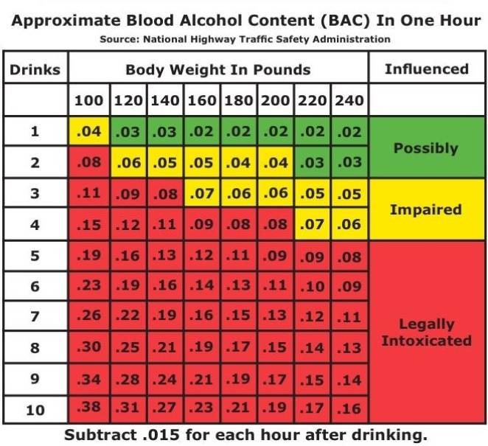

Figure 15 - BAC Time Table

|  |  |  |  |  |  |
| --- | --- | --- | --- | --- | --- |
| Drinks | Weight | 1 | 2 | 3 | 4 |
| Person 1 | 150 | 0.02 | 0.05 | 0.08 | N/A |
| Person 2 | 185 | N/A | 0.02 | 0.05 | 0.08 |
| Person 3 | 170 | 0.02 | 0.04 | 0.06 | 0.09 |

Figure 1 – Results from observational study

**Results & Discussion**

The difficulties in the design itself were mostly anticipated knowing that the nature of a Capstone project would entail challenges. To take a project from concept to developing a finished product is an achievement that highlights the learning outcomes of an entry level engineer. However, some issues became a learning experience. When soldering, safety precautions were not all accounted for; I did have ventilation so that I was not breathing in any fumes, but I forgot to wear eye goggles. I came to this realization after some solder exploded on a hot pin, so I am glad I still have my vision. Another issue I overlooked is with spacing when designing my PCB. The diameter of the piezo buzzer pins is too large for the diameter of the pads. I wanted to know if I overlooked this portion of my research, but I see no mention of pin dimensions in the manufacturer’s product specifications (CEP-1130, N.D.) . The digital I/O pins were another issue as they did not become flush with the female connections of the Arduino board, the male connector needed to be rewired using hand tools. This could have been fixed in the design phase of the PCB to ensure correct spacing. In the end, the device still functions as desired, and I now have a working breathalyzer.

**Limitations**

The results of my independent study left a little room for error but was mostly correct. It is important to note that this table only details an approximate value for BAC, as there are other factors that could affect the result. BACtrack disclaims that, “the effects of alcohol intoxication are greatly influenced by individual variations among users” (BACtrack GO, N.D.). Since alcohol affects everyone a little differently due to physical attributes, some users would underestimate or overestimate the results of the breathalyzer test. As a result, my design is passable if acknowledging that drinking any amount can impair the body’s motor functions. In passing, this will also support affordable alternatives in order to be more positive about conscious alcohol consumption.

**Future Work**

This design could use a case, but due to time constraints, one could not be fabricated without spending more resources. Other features could also be implemented in the code, such as a automatic off program, or even a thermistor that could sense when the MQ-3 sensor was fully warmed up.

**References**

*Alcohol Gas Sensor* (2014). *Winsen* [PDF]. V 1.3. Retrieved from <https://cdn.sparkfun.com/datasheets/Sensors/Biometric/MQ-3%20ver1.3%20-%20Manual.pdf%20>

*BACtrack GO* (N.D.). BACtrack [PDF]. Retrieved from <https://cdn.shopify.com/s/files/1/0177/6214/files/BACtrack_Go_Keychain_Breathalyzer.pdf?10875855552948158797>

B.I. Bakare, A. Umoru, & S. Orike. (2020). *Improved Alcohol Level Sensing Device that Transmit Offender’s Data to a Central Server through Short Messaging Service*. EJECE, European Journal of Electrical Engineering and Computer Science. Vol. 4, No. 5. P. 1-6. Retrieved from <https://pdfs.semanticscholar.org/f476/3a8f28ed9ac6af59620db0500ea211f5e496.pdf>

Blood Alcohol Level. (N.D.). The University of Toledo. Retrieved from <https://www.utoledo.edu/studentaffairs/counseling/selfhelp/substanceuse/bac.html>

Carey, K. & Hustad, J. (2005). *Comprehensive Handbook of Alcohol Related Pathology*. Elsevier Ltd.

CEP-1130. (N.D.). Digi-Key. Retrieved from <https://www.digikey.com/en/products/detail/cui-devices/CEP-1130/412398>

Ighalo, J., Uzairue, S., Ochonogor, C., Amaize, P., Okokopujie, K., (March, 2019). *Development of alcohol triggered vehicle engine lock system*. International Journal of Robotics and Automation (IJRA) Vol.8, No.1, March 2019, pp. 68~76

Lee, D., Gao, G., Jeong, S., & Shih, P. C. (2020). *Design and assessment of a personal breathalyzer intervention to support responsible drinking*. International Journal of Human - Computer Studies, 137. <https://doi.org/10.1016/j.ijhcs.2019.102382>

*Specifications of LCD Module*. (2008). Xiamen Amotec Display Co [PDF]. Retrieved from <https://components101.com/sites/default/files/component_datasheet/16x2%20LCD%20Datasheet.pdf>

*Technical Data MQ-3 Gas Sensor* (N.D.). Hanwei Electronics [PDF]. Retrieved from <https://www.sparkfun.com/datasheets/Sensors/MQ-3.pdf>